SYSTEM DESIGN
Data Flow Diagram / Use Case Diagram / Flow Diagram
The DFD is also called as bubble chart. It is a simple graphical formalism that can be used to represent a system in terms of the input data to the system, various processing carried out on these data, and the output data is generated by the system.

SEQUENCE DIAGRAM:
AUTHORITY:
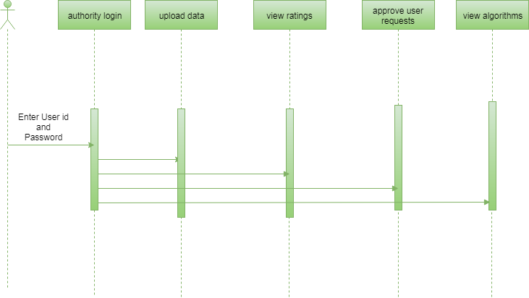

DEVELOPER:

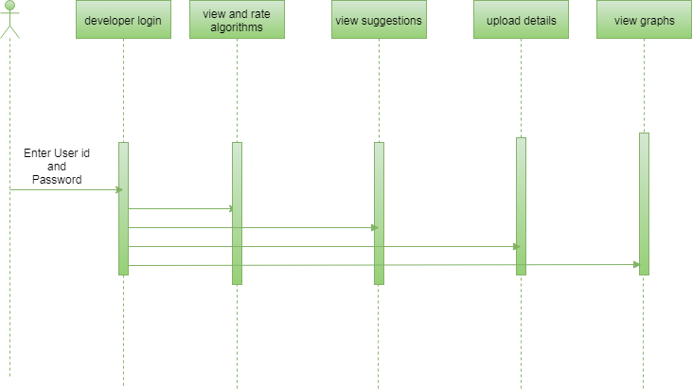

ACTIVITY DIAGRAM:
AUTHORITY:

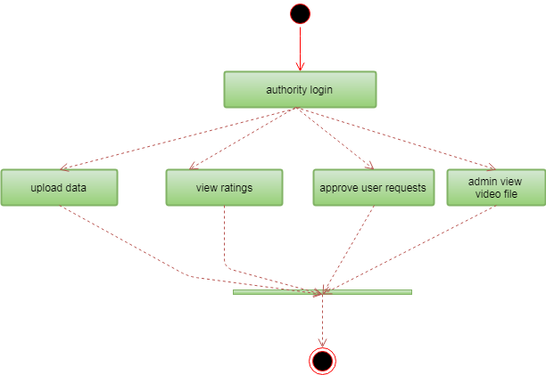

DEVELOPER:

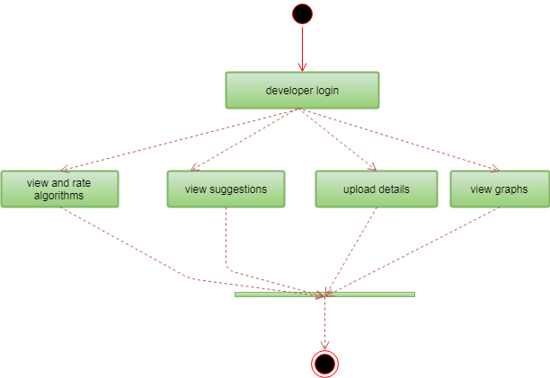

USECASE DIAGRAM:
AUTHORITY:
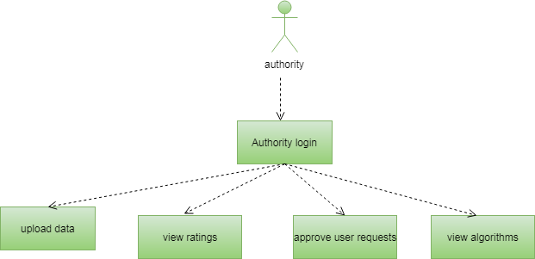

DEVELOPER:

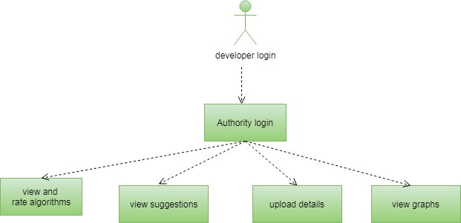

COMPONENT DIAGRAM:

AUTHORITY:
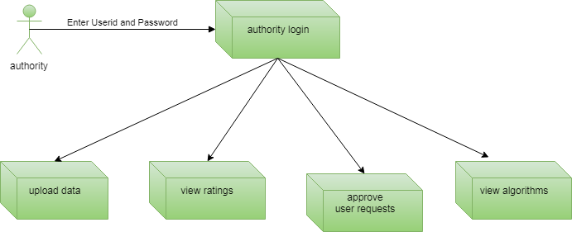

DEVELOPER:
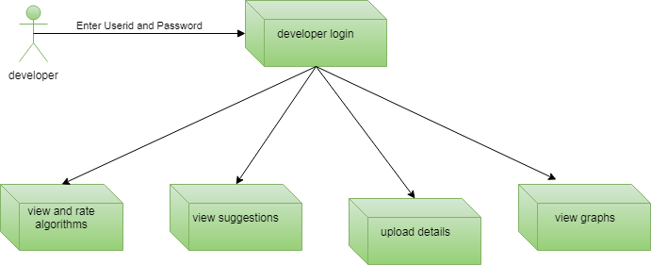

CLASS DIAGRAM:

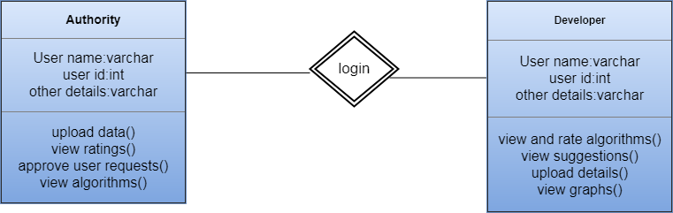

ER DIGRAM:
AUTHORITY:
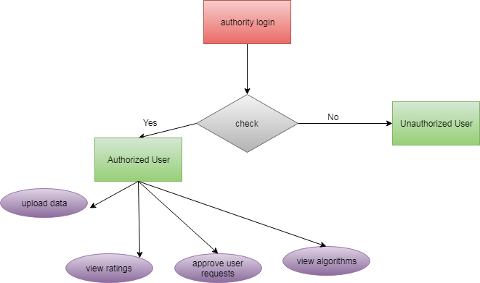

DEVELOPER:

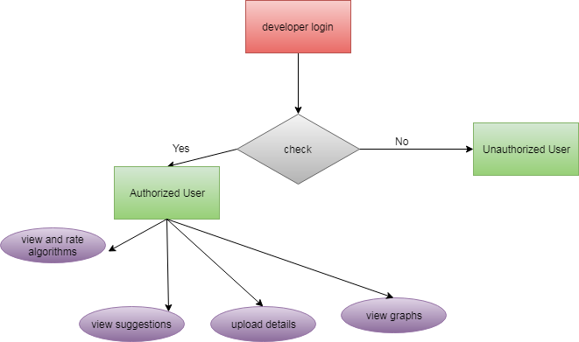

DATA FLOW DIAGRAM:
AUTHORITY:
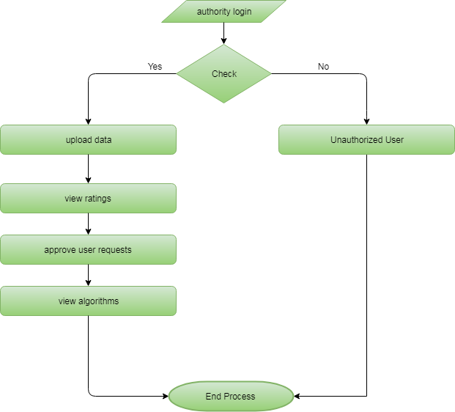

DEVELOPER:

